iMedRIS Quick Guide
Tracking an Application
iMedRIS version: 11.01
:
Last Revised: 10.28.2020
Please see the guidance below for how to track your iMedRIS application. When loading the tracking page in iMedRIS please give the page a few seconds to load.

Step-by-Step Instructions

- Log into iMedRIS using your NetID (https://imedris.uthsc.edu/). | 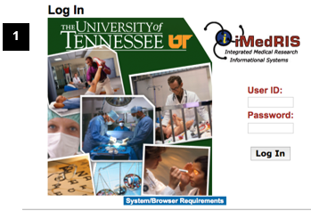1
- Alternately, on the top left of your iMedRIS home page, hover your mouse over the My Workspaces drop-down symbol. Then move you mouse to hover over Project Assistant.  - Click on View My Projects. | 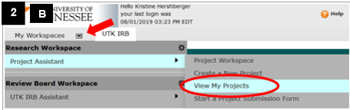
- Click on the notepad to open your project. | 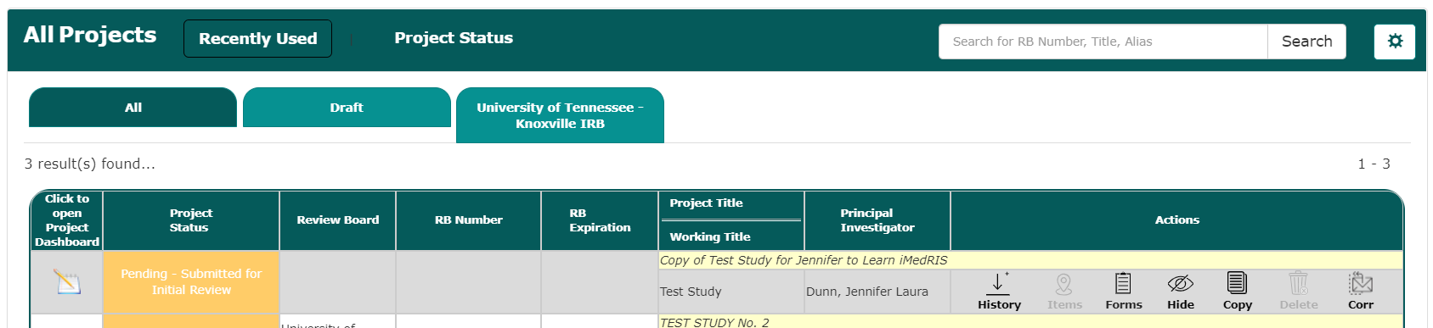
- Click on the colored box. It may be either green or yellow depending on the status of the submission. | 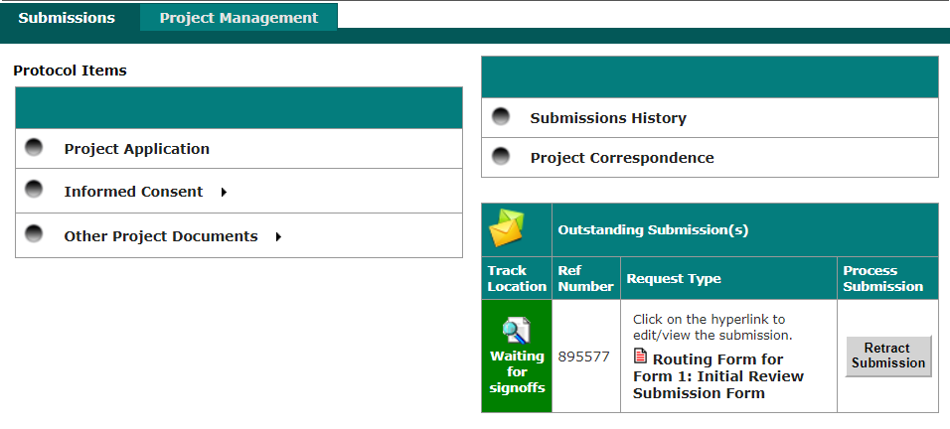
- If the box says Waiting for Signoff, your submission tracking status will look like the following:  - Click on the orange bubble in the diagram to see what step your application is on in the approval process  - If anything in the column labelled Task Status says received then you are waiting for a signature from that individual. | 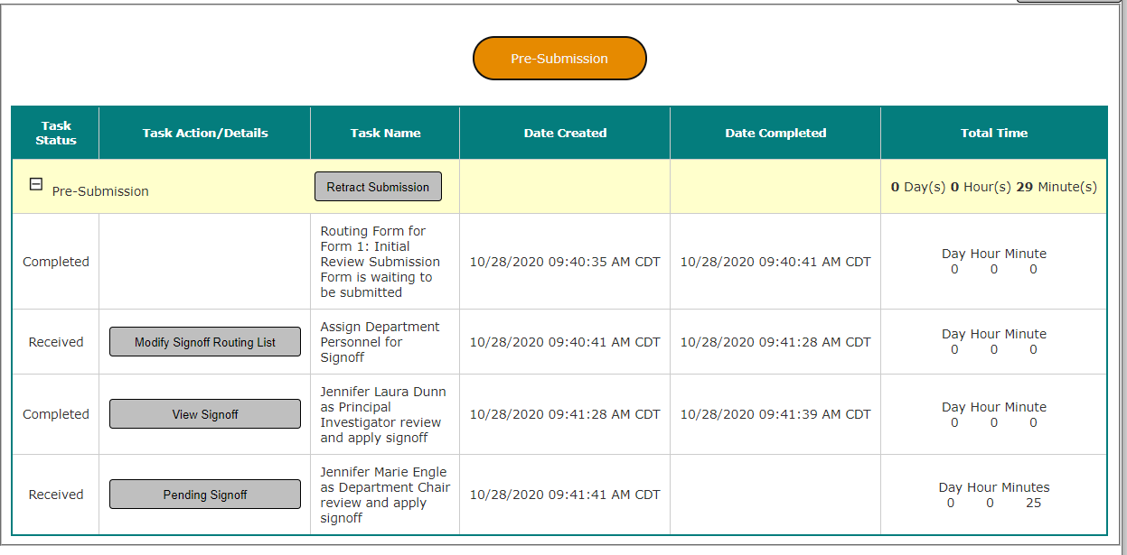
- If the box says Routing in Process, your submission tracking status will look similar to this:  - Click on the orange bubble in the diagram to see what step your application is on in the approval process  - Please check the column labelled Task Status to see where your project is in the process | 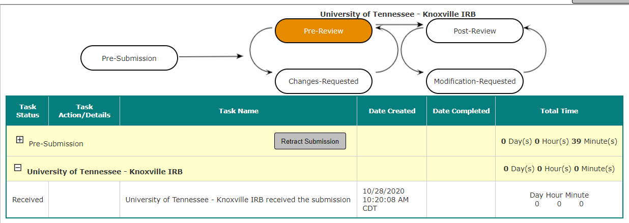

Document History
Date | Summary of Changes
10.26.2020 | Original Approval

